**SCREENSHOTS AND DESCRIPTION OF THE PROJECT**

**CANDIDATE SIDE**

**INDEX PAGE**



**Filename:** Index1.html

**Description:** First page of the website talHub.com

**ABOUT US PAGE**



**Filename:** About.html

**Description:** This page talks about the team mates of the project.

**LOGIN PAGE**

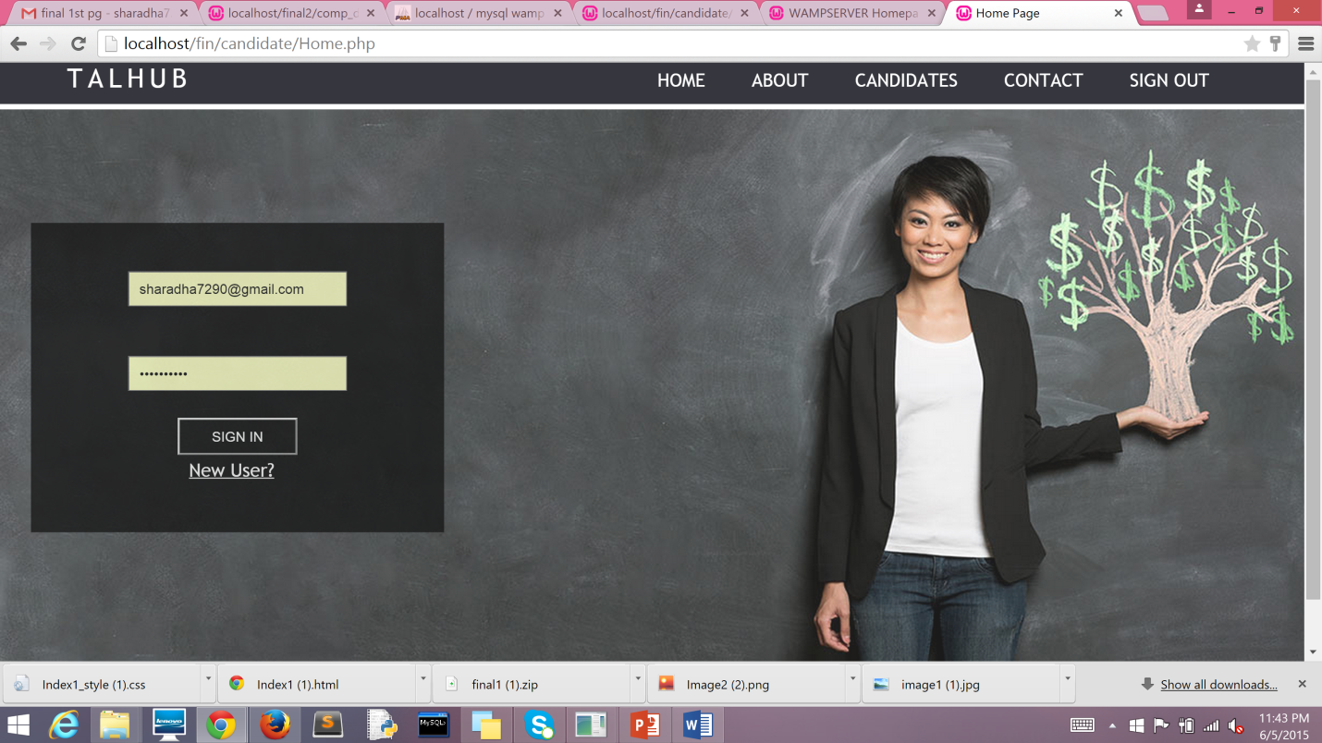

**Filename:** Home.php

**Description:** User login page

**Existing username:** [sharadha7290@gmail.com](mailto:sharadha7290@gmail.com) **Existing username:** Thenu@7290

**CANDIDATE REGISTER PAGE**

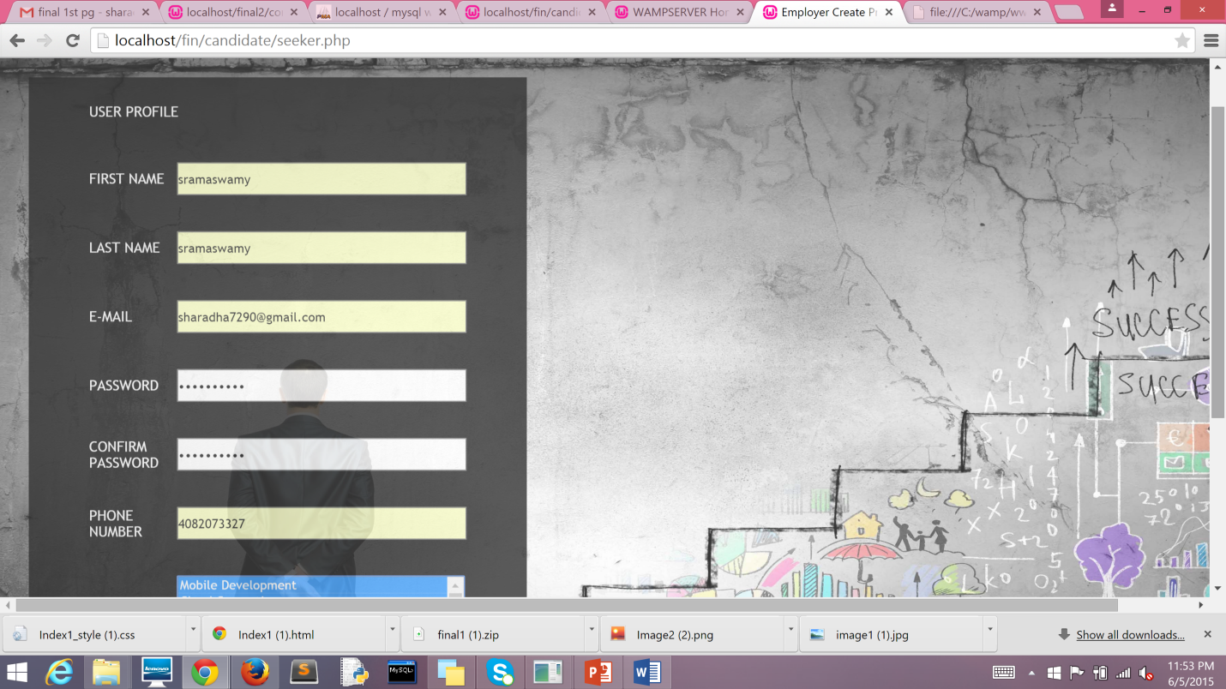

**Filename:**

**Description:** The page above registers the details of the candidate. The details captured are first name, last name, e-mail, and password, confirm password, phone number, skill sets, resume.

**CANDIDATE DASHBOARD**

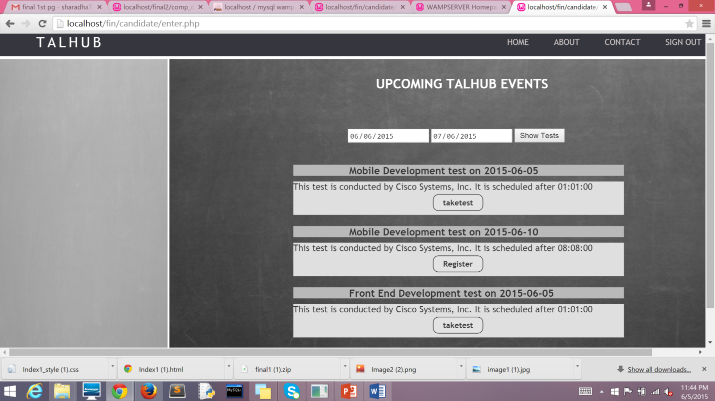

**Filename:** Main_template.php

**Description:** Displays the upcoming tests and details of the test (Company, date, time). If the time has not lapsed for the test, Register button will be enabled. Upon clicking the register button, take test button will be activated. The candidate can take up the test.

**CANDIDATE DASHBOARD**

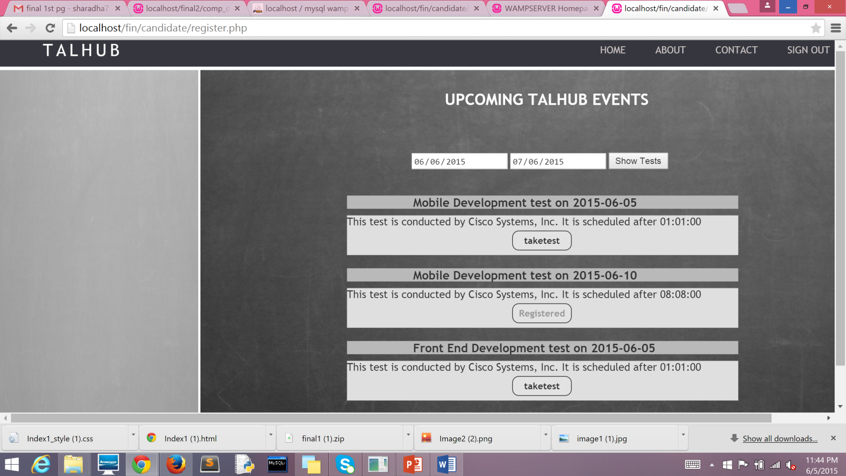

**Filename:** Main_template.php

**Description:** The page above shows the register button for elapsed time. The candidate will not be able to take the test once the time has lapsed

**CANDIDATE DASHBOARD**

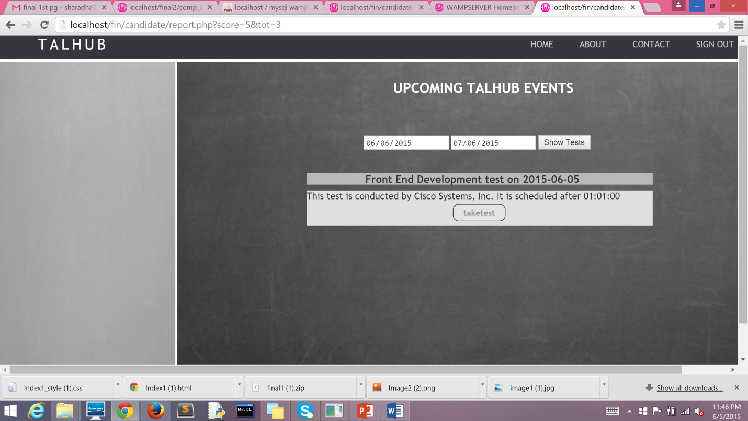

**Filename:** Main_template.php

**Description:** Display of the take test button disable as the time has lapsed.

**FIRST LEVEL SCREENING -TEST PAGE**

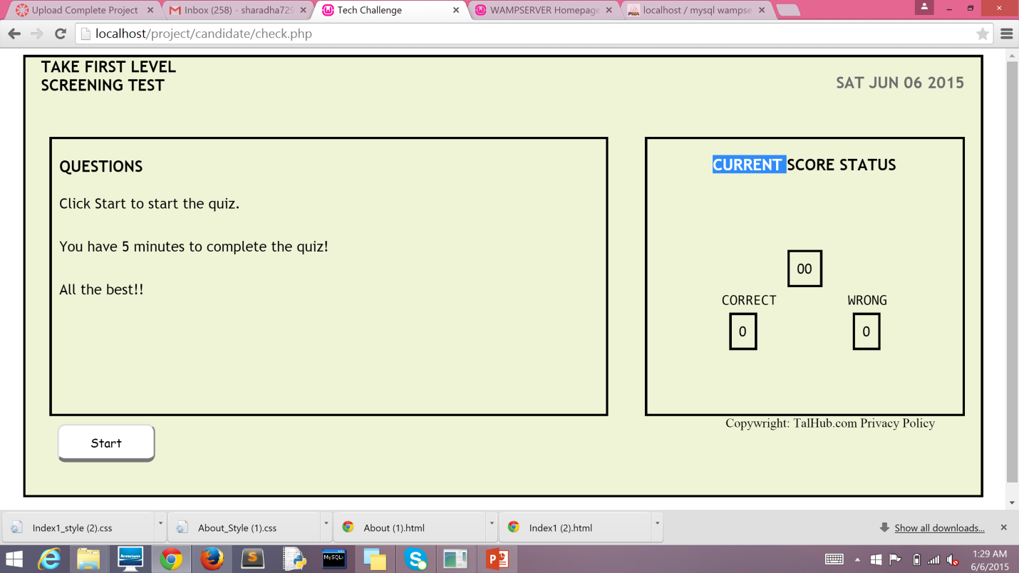

**Filename:** index.php

**Description:** Test will be launched once the candidate clicks the take test button.

**TEST PAGE**

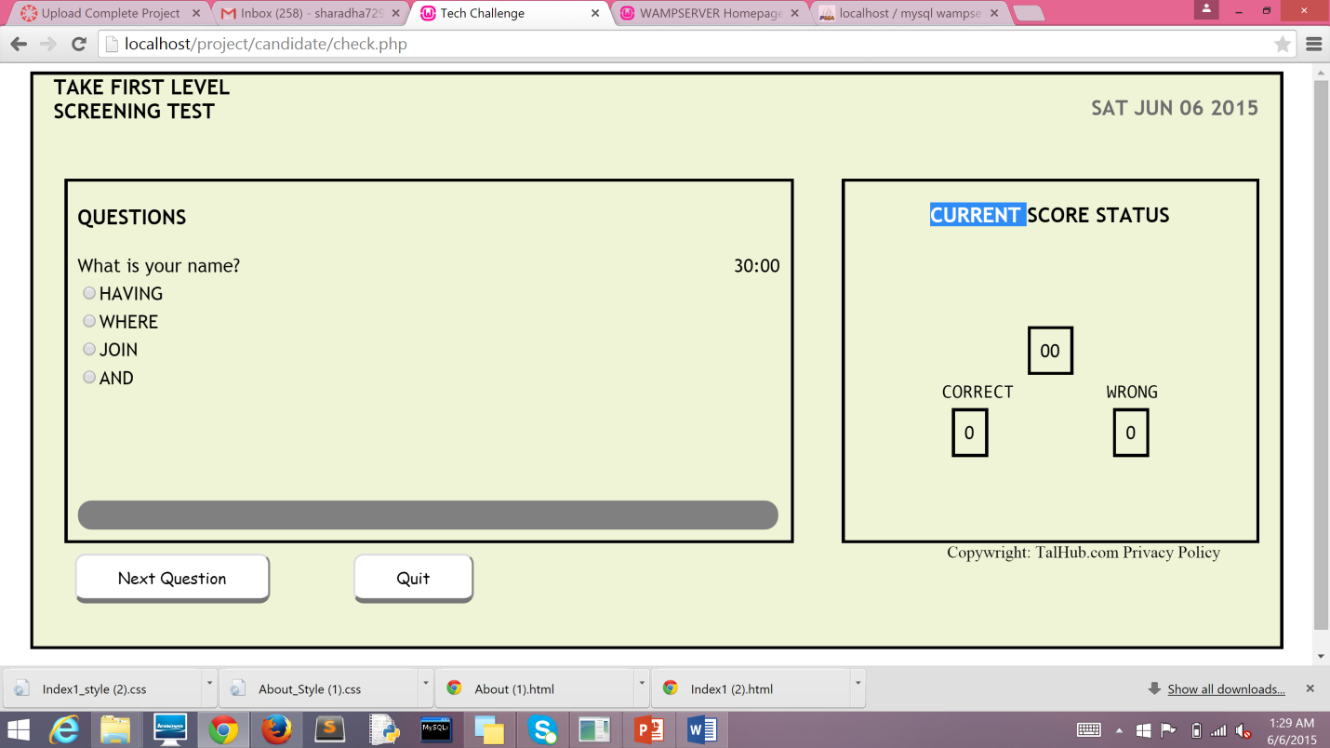

**Filename:** index.php

**Description:** The above page will be displayed once the user clicks start

**COMPANY SIDE**

**COMPANY REGISTRATION PAGE**

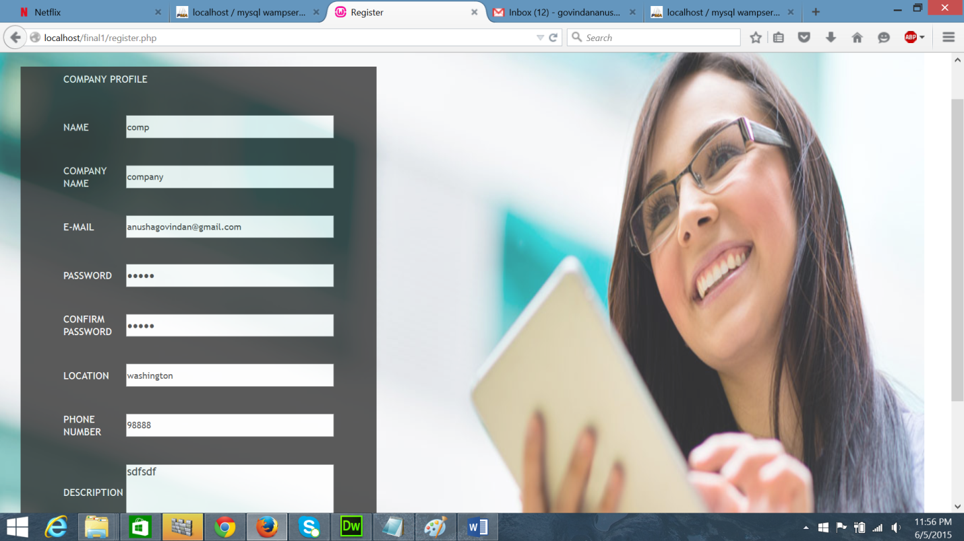

**Filename:** register.php

**Description:** Company can register with us on this page. The details recorded are employee name, company name, e-mail, password, confirm password, location, phone number, description of the company.

**COMPANY LOGIN PAGE**

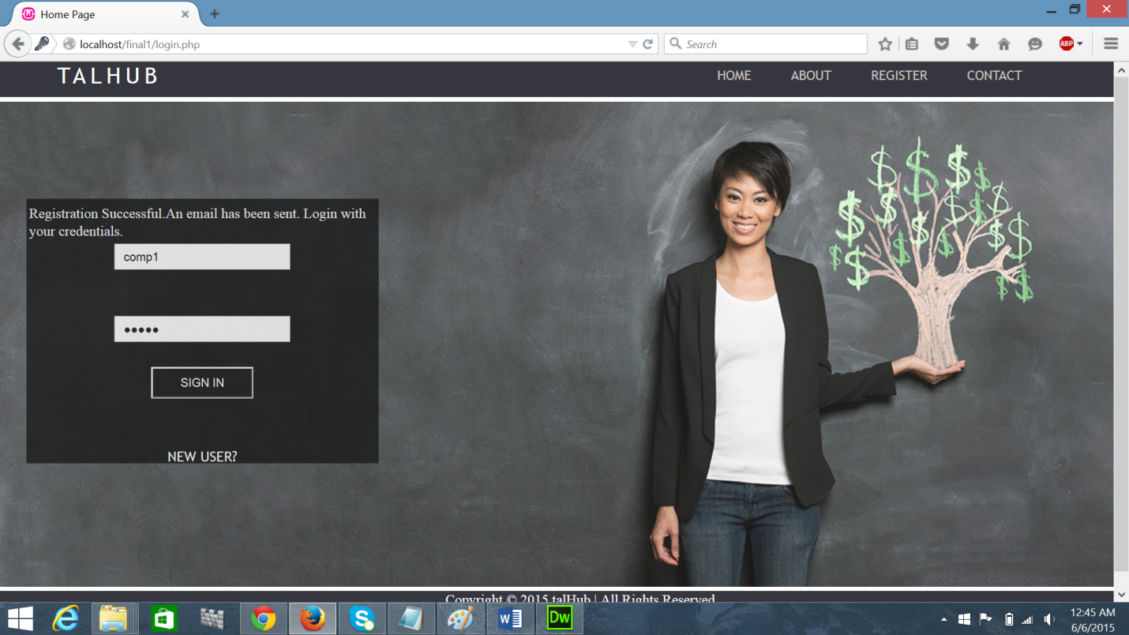

**Filename:** login.php

**Description:** the company user login page.

**USER CREDENTIALS FOR VERIFICATION** – **USERNAME:** comp **PASSWORD:** hello

**phpMAILER**

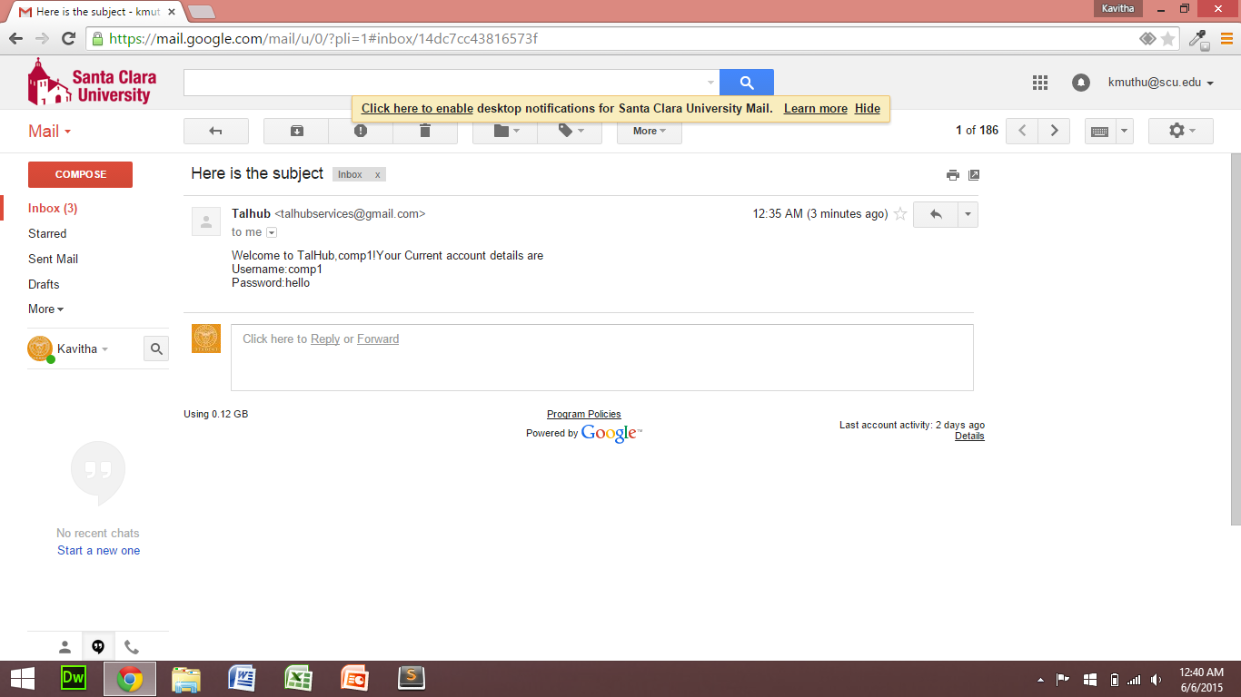

**Description:** Once the user account is created, a mail is sent with the username and password to the company.

**COMPANY VIEW PROFILE**

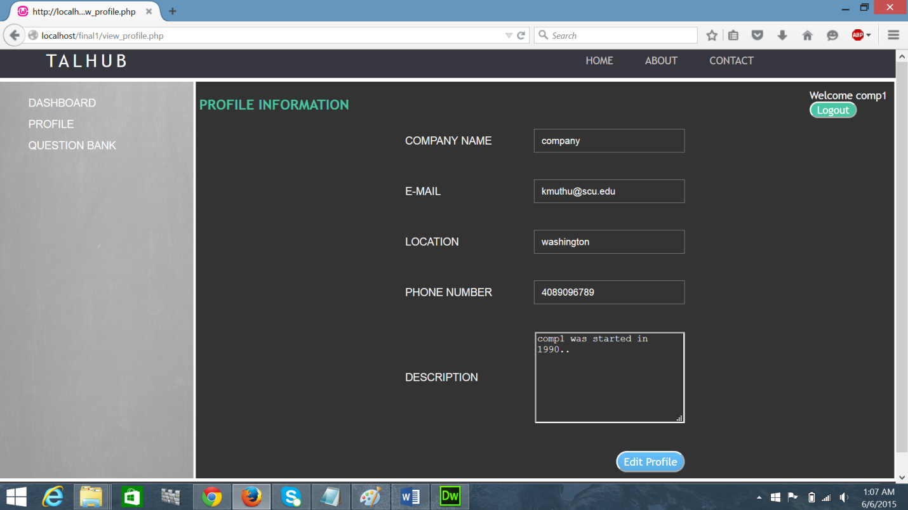

**Filename:** View_profile.php.

**Description:** Displays the user information.

**COMPANY EDIT PROFILE**

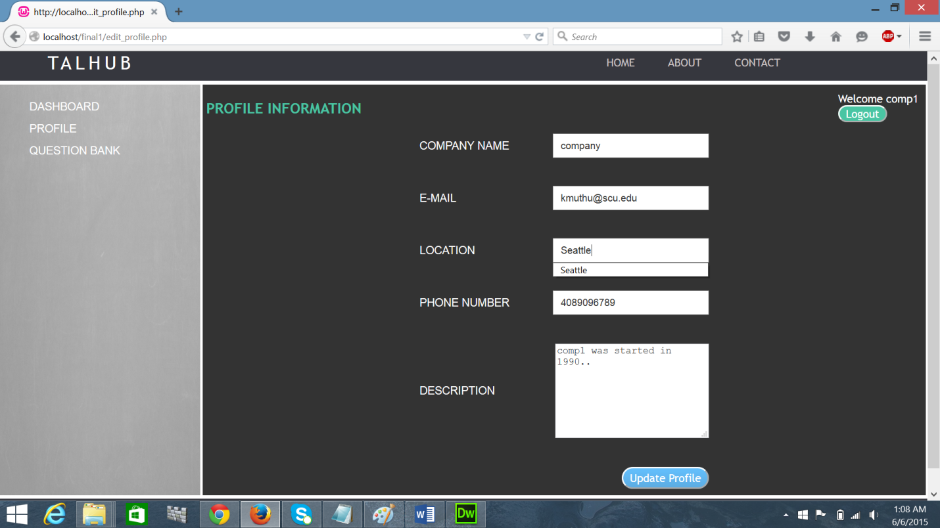

**Filename:** edit_profile.php

**Description:** The page above enables the user to edit information. On the click of update profile the updated value will be displayed.

COMPANY PROFILE - VIEW OF EDITED VALUE.

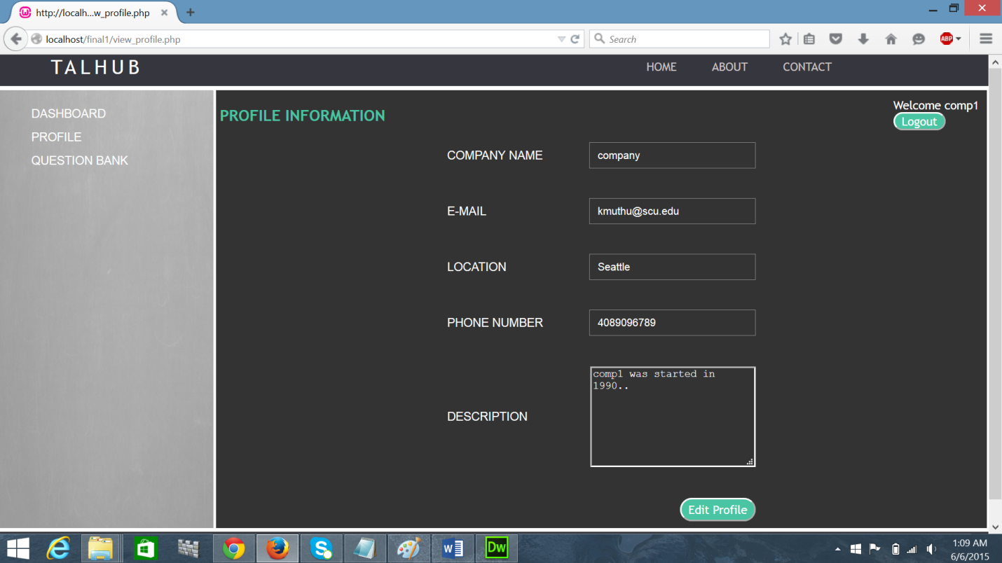

**Filename:** View_profile.php

**Description:** The value for location is updated to Seattle from Washigton**.**

**COMPANY DASHBOARD**

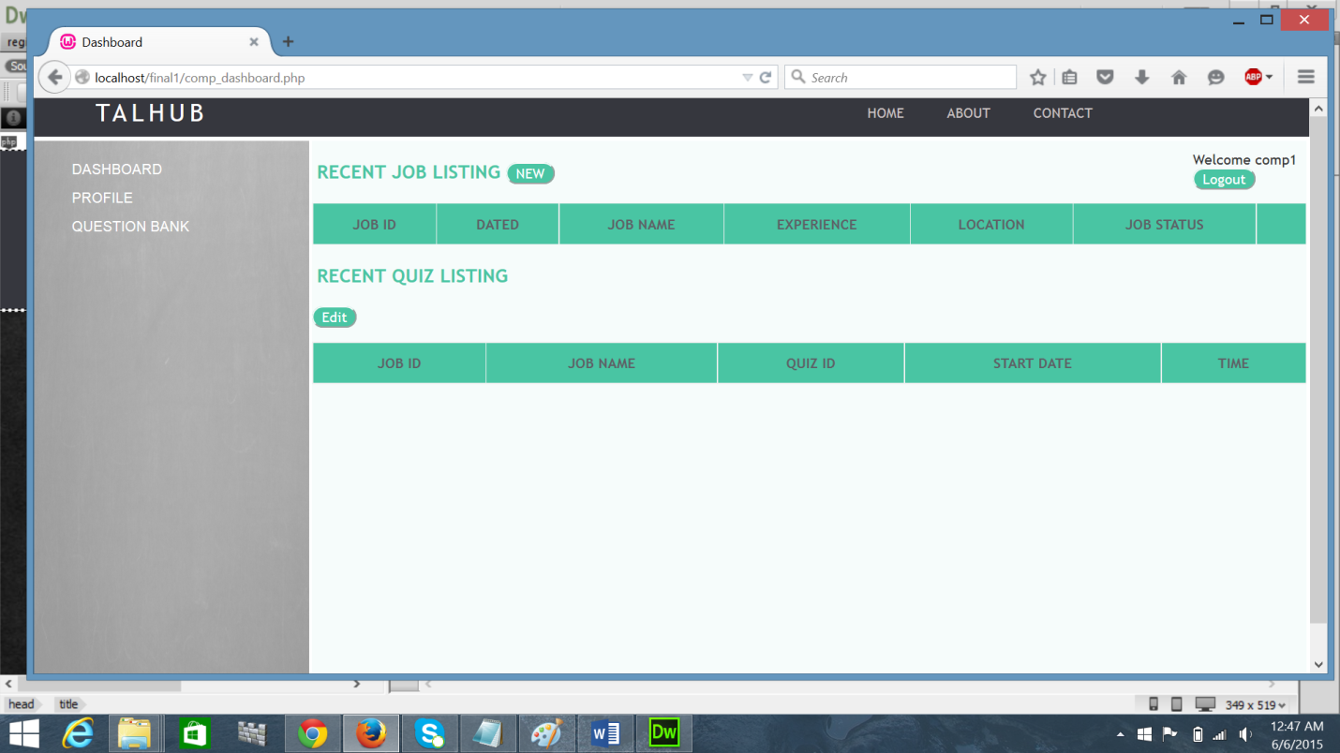

**Filename:** dashboard.php

**Description:** The page above displays the dashboard of the company once the valid username and password is given.

**CREATE NEW JOB – Step 1**

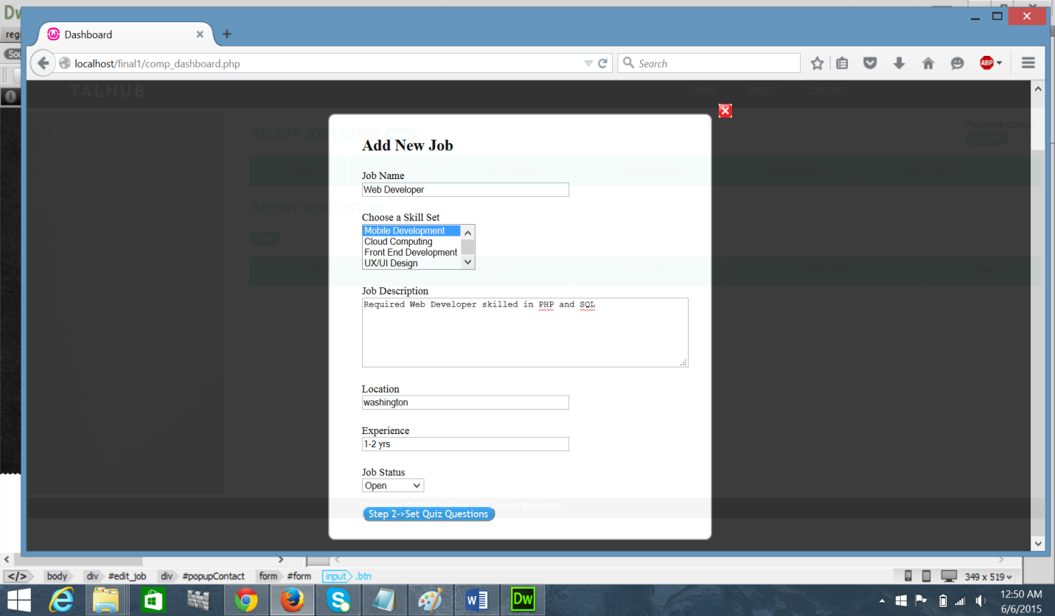

**Filename:** dashboard.php

**Description:** Add new job form will be generated when the new button under job listings is clicked in the dashboard page. The details recorded are job name, skill set, job description, location, experience, job status.

**CREATE QUIZ – Step 2**

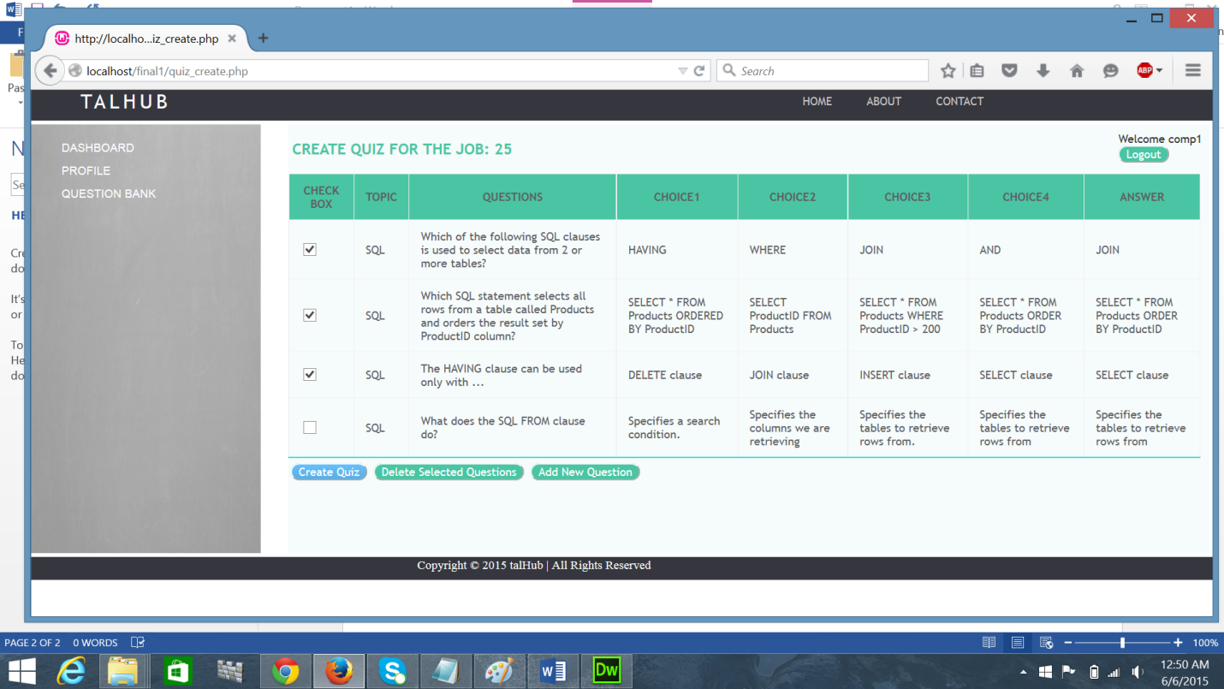

**Filename:** dashboard.php

**Description:** The second step involves creating a quiz. The employee can choose the questions from the question bank. Here the user can delete questions and add new questions.

**PREVIEW OF QUESTIONS SELECTED – Step 3**

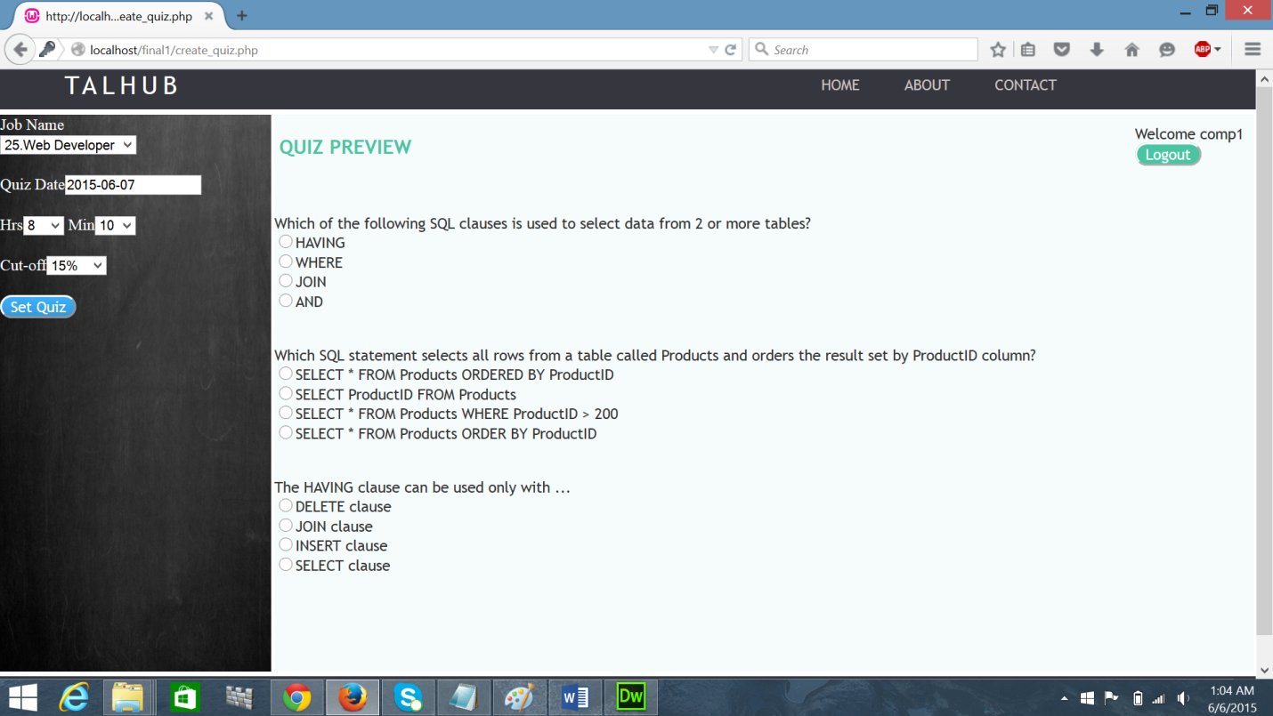

**Filename:** dashboard.php

**Description:** This page shows a preview of the questions selected for the quiz. Here the user can set the job title, quiz date, time and the eligibility criteria for the candidates.

**COMPANY DASHBOARD**

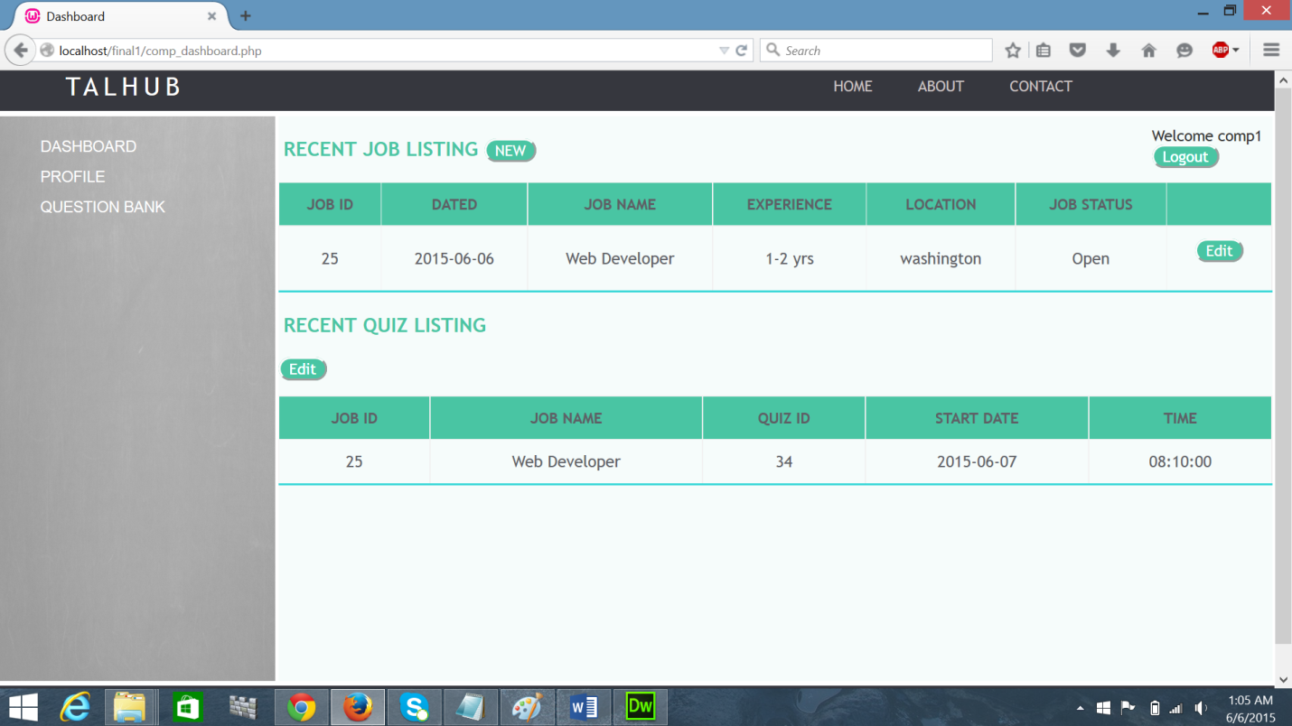

**Filename:** quiz_create.php

**Description:** Job created by the user and the quiz details are displayed.

**EDIT QUIZ PAGE**

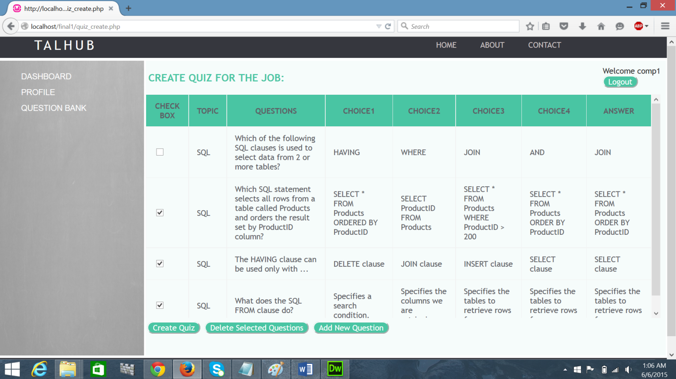

**Filename**: quiz_create.php

**Description**: On click of the edit button in the previous page, the following page will be generated.This page enables the user to edit the questions to be added to the quiz.

**ADD NEW QUESTION**

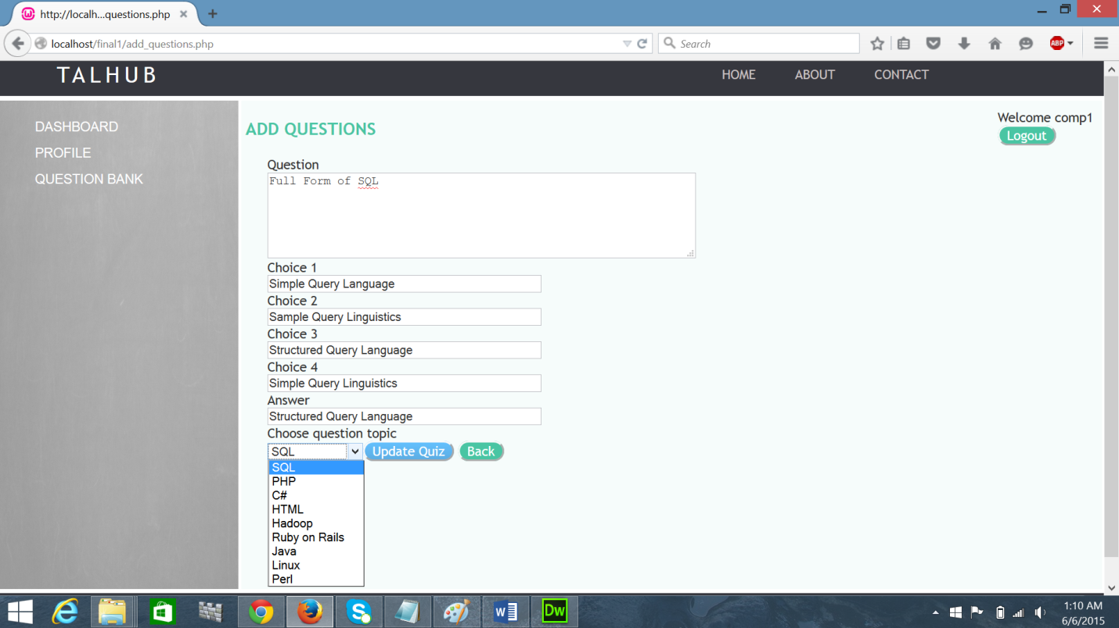

**Filename:** add_questions.php

**Description:** New questions can be added to the question bank using this form.

**REFERENCES**

Google images

* [www.phptutorial.com](http://www.phptutorial.com)
* [www.stackoverflow.com](http://www.stackoverflow.com)
* <http://www.webdeveloper.com/forum/showthread.php?49403-how-to-make-images-change>
* [www.w3schools.com](http://www.w3schools.com)
* [www.hired.com](http://www.hired.com)
* [www.toptal.com](http://www.toptal.com)
* <http://thenextweb.com/apps/2011/06/17/spill-empathy-comes-online-saving-lives-in-the-process/>
* <http://www.hecticgeek.com/2011/11/free-cross-platform-file-download-upload-manager-jdownloader/>
* <http://designscrazed.org/html5-jquery-file-upload-scripts/>